Comprehensive Assignment 07
Evidence
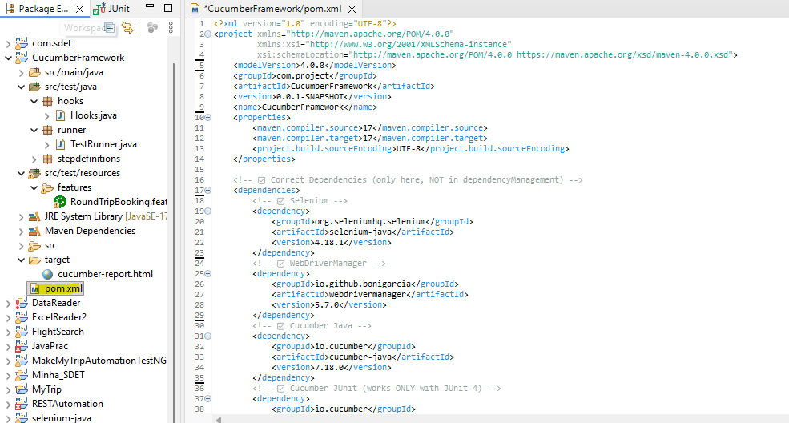
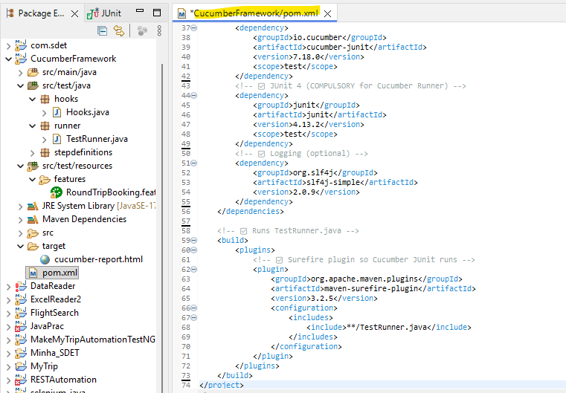
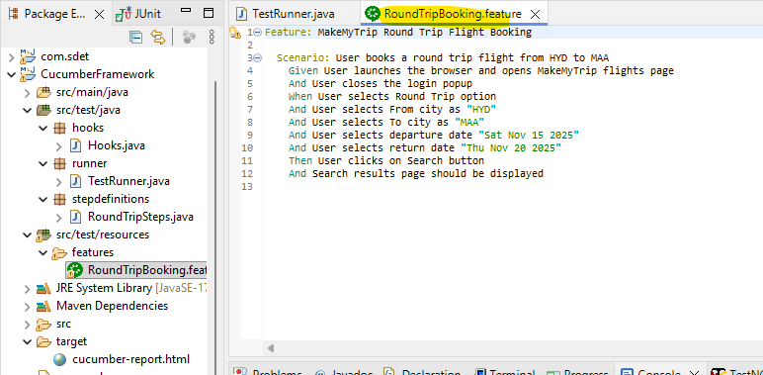
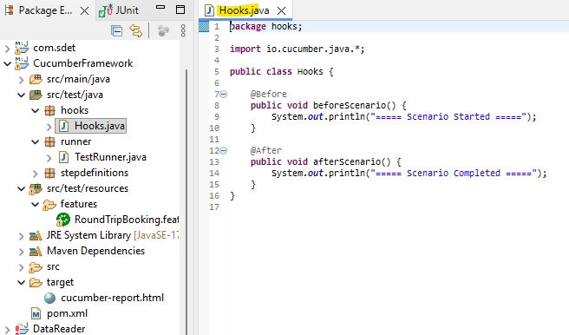
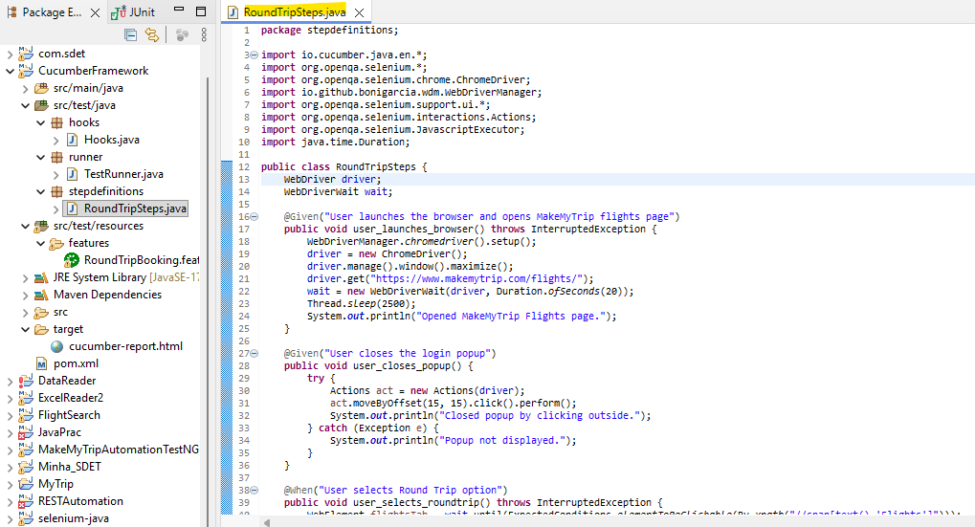
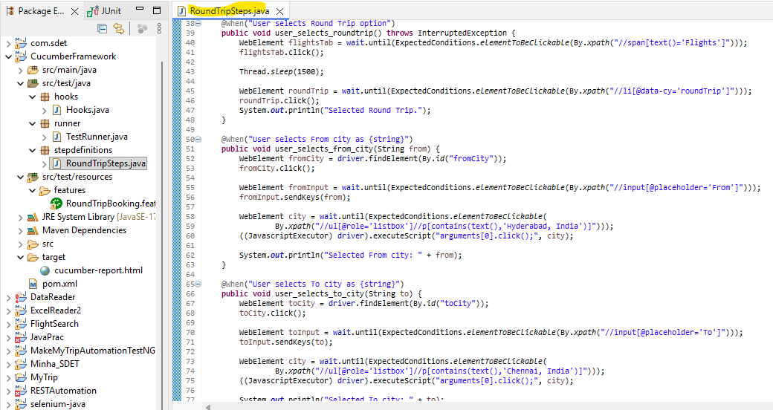
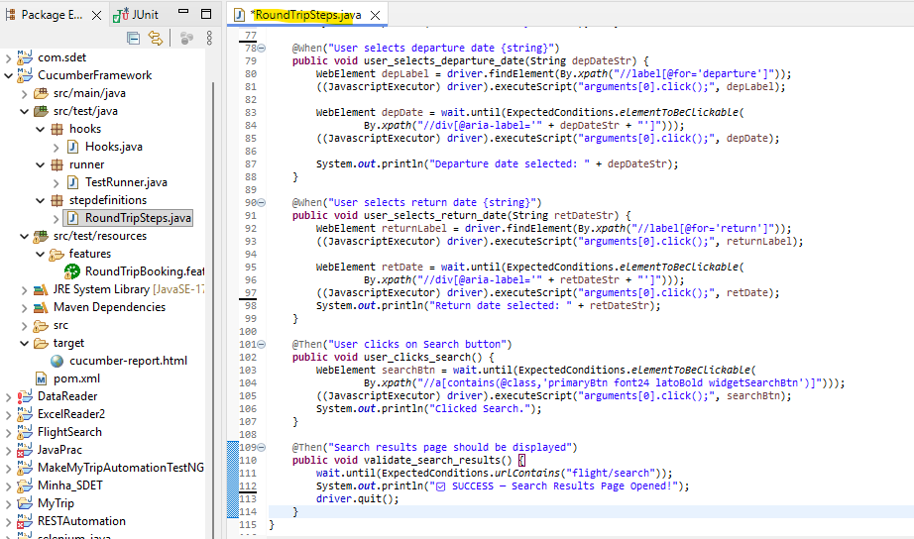
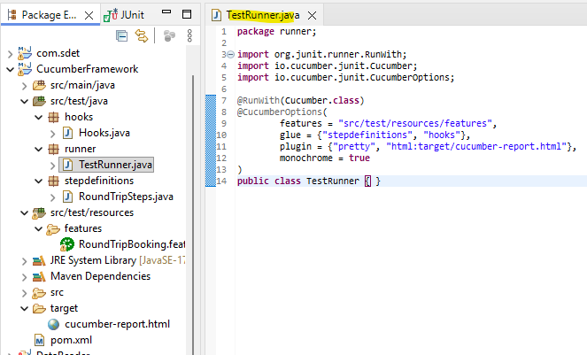
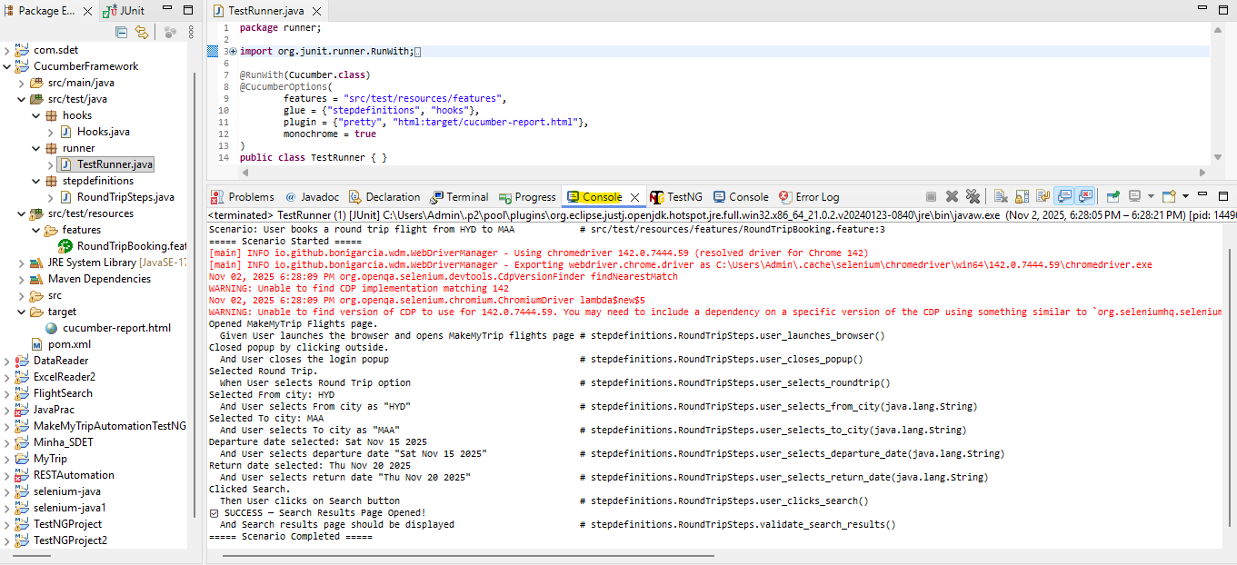
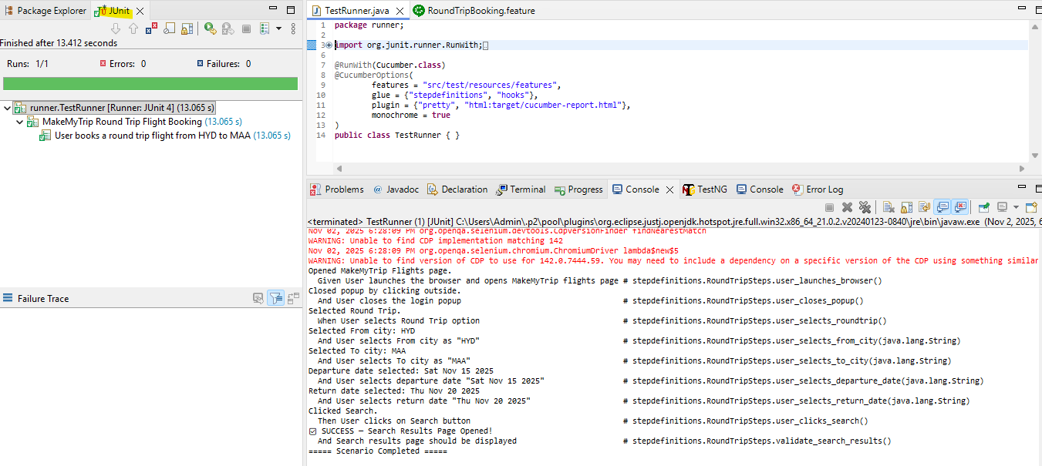
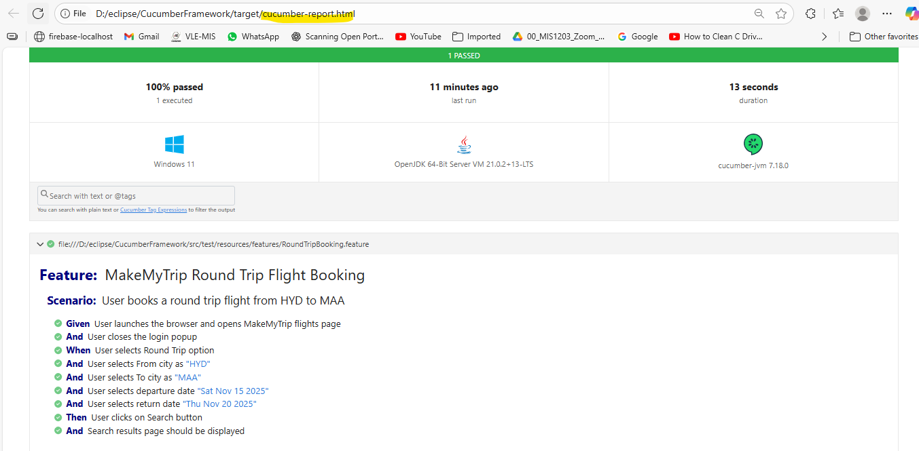

package stepdefinitions;

import io.cucumber.java.en.*;
import org.openqa.selenium.*;
import org.openqa.selenium.chrome.ChromeDriver;
import io.github.bonigarcia.wdm.WebDriverManager;
import org.openqa.selenium.support.ui.*;
import org.openqa.selenium.interactions.Actions;
import org.openqa.selenium.JavascriptExecutor;
import java.time.Duration;

public class RoundTripSteps {
WebDriver driver;
WebDriverWait wait;

@Given("User launches the browser and opens MakeMyTrip flights page")
public void user_launches_browser() throws InterruptedException {
WebDriverManager.chromedriver().setup();
driver = new ChromeDriver();
driver.manage().window().maximize();
driver.get("https://www.makemytrip.com/flights/");
wait = new WebDriverWait(driver, Duration.ofSeconds(20));
Thread.sleep(2500);
System.out.println("Opened MakeMyTrip Flights page.");
}

@Given("User closes the login popup")
public void user_closes_popup() {
try {
Actions act = new Actions(driver);
act.moveByOffset(15, 15).click().perform();
System.out.println("Closed popup by clicking outside.");
} catch (Exception e) {
System.out.println("Popup not displayed.");
}
}

@When("User selects Round Trip option")
public void user_selects_roundtrip() throws InterruptedException {
WebElement flightsTab = wait.until(ExpectedConditions.elementToBeClickable(By.xpath("//span[text()='Flights']")));
flightsTab.click();

Thread.sleep(1500);

WebElement roundTrip = wait.until(ExpectedConditions.elementToBeClickable(By.xpath("//li[@data-cy='roundTrip']")));
roundTrip.click();
System.out.println("Selected Round Trip.");
}

@When("User selects From city as {string}")
public void user_selects_from_city(String from) {
WebElement fromCity = driver.findElement(By.id("fromCity"));
fromCity.click();

WebElement fromInput = wait.until(ExpectedConditions.elementToBeClickable(By.xpath("//input[@placeholder='From']")));
fromInput.sendKeys(from);

WebElement city = wait.until(ExpectedConditions.elementToBeClickable(
By.xpath("//ul[@role='listbox']//p[contains(text(),'Hyderabad, India')]")));
((JavascriptExecutor) driver).executeScript("arguments[0].click();", city);

System.out.println("Selected From city: " + from);
}

@When("User selects To city as {string}")
public void user_selects_to_city(String to) {
WebElement toCity = driver.findElement(By.id("toCity"));
toCity.click();

WebElement toInput = wait.until(ExpectedConditions.elementToBeClickable(By.xpath("//input[@placeholder='To']")));
toInput.sendKeys(to);

WebElement city = wait.until(ExpectedConditions.elementToBeClickable(
By.xpath("//ul[@role='listbox']//p[contains(text(),'Chennai, India')]")));
((JavascriptExecutor) driver).executeScript("arguments[0].click();", city);
System.out.println("Selected To city: " + to); }

@When("User selects departure date {string}")
public void user_selects_departure_date(String depDateStr) {
WebElement depLabel = driver.findElement(By.xpath("//label[@for='departure']"));
((JavascriptExecutor) driver).executeScript("arguments[0].click();", depLabel);

WebElement depDate = wait.until(ExpectedConditions.elementToBeClickable(
By.xpath("//div[@aria-label='" + depDateStr + "']")));
((JavascriptExecutor) driver).executeScript("arguments[0].click();", depDate);

System.out.println("Departure date selected: " + depDateStr);
}

@When("User selects return date {string}")
public void user_selects_return_date(String retDateStr) {
WebElement returnLabel = driver.findElement(By.xpath("//label[@for='return']"));
((JavascriptExecutor) driver).executeScript("arguments[0].click();", returnLabel);

WebElement retDate = wait.until(ExpectedConditions.elementToBeClickable(
By.xpath("//div[@aria-label='" + retDateStr + "']")));
((JavascriptExecutor) driver).executeScript("arguments[0].click();", retDate);
System.out.println("Return date selected: " + retDateStr);
}

@Then("User clicks on Search button")
public void user_clicks_search() {
WebElement searchBtn = wait.until(ExpectedConditions.elementToBeClickable(
By.xpath("//a[contains(@class,'primaryBtn font24 latoBold widgetSearchBtn')]")));
((JavascriptExecutor) driver).executeScript("arguments[0].click();", searchBtn);
System.out.println("Clicked Search.");
}

@Then("Search results page should be displayed")
public void validate_search_results() {
wait.until(ExpectedConditions.urlContains("flight/search"));
System.out.println("✅ SUCCESS — Search Results Page Opened!");
driver.quit();
}
}

